2)

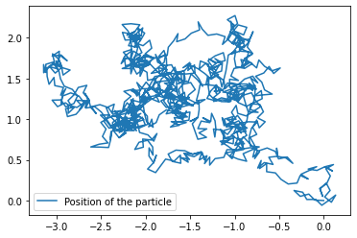

Figure 1: This figure shows the position of the particle as it undergoes its random walk, starting from (0,0).

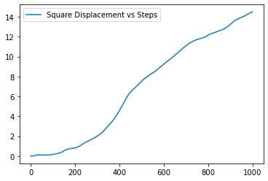

Figure 2: This figure shows the displacement squared of the particle as a function of time.

The step size of the random walk seen in Figure 1 is 0.1, with the number of steps being one thousand. The average displacement of the particle over the entire walk for one simulation of the thousand step random walk was about 0.692. This is somewhat consistent with the expected average of zero that was predicted in class. The expected value for the mean square displacement for a 2 dimensional random walk that was predicted in class was 2Nb2, with N being the number of steps and b being the step size. The value after 1000 steps that was obtained during one run of the random walk is about 14.5, which is a little less than the expected value of 20.

3)

Figure 3: This figure shows the log10 of mean square displacement vs log10 of time of the Brownian Particle.

The beginning of the plot in Figure 3 has points around (-9,-14) and (-8,-12). The slope between these two points is 2. Towards the end of the plot, the points are nearly (-6,-8.5) and (-5,-7). The slope between these two points is 1.5, which is close to one. Since Figure 3 is a log-log plot, the slopes correspond to the power of the relationship between mean square displacement and time. This means that this relationship is quadratic at the start and ends being closer to a linear relationship. From Figure 3, the slope of the line seems to decrease around when log10(time) = -7, corresponding to a time of 10-7 seconds. This agrees with what we determined in class of the mean square displacement being proportional to time (linear) on timescales >> 10-7.